DATA HANDLING AND VISUALIZATION USING R
ASSIGNMENT 13 – GEOGRAPHIC DATA
DATASET
City | Population | Avg. Temperature | Elevation
City A | 500000 | 75 | 1000
City B | 700000 | 68 | 800
City C | 600000 | 80 | 1200
Note: The original dataset does not contain latitude and longitude. For Question 1, illustrative coordinates are used only to demonstrate the map visualization.
QUESTION 1: Create a map chart to visualize the distribution of cities on a geographic map. Label the map elements.
AIM
To create a map chart showing the geographic distribution of City A, City B, and City C and label the cities.
ALGORITHM
1. Create the geographic data frame.
2. Add illustrative latitude and longitude values to the three cities.
3. Load ggplot2 and ggrepel packages.
4. Plot longitude on the X-axis and latitude on the Y-axis.
5. Represent population using point size and label each city.
6. Display the map chart.
R CODE
data <- data.frame(
City = c("City A", "City B", "City C"),
Population = c(500000, 700000, 600000),
Avg_Temperature = c(75, 68, 80),
Elevation = c(1000, 800, 1200)
)
library(ggplot2)
library(ggrepel)
data$Longitude <- c(80.0, 80.5, 80.2)
data$Latitude <- c(13.0, 13.3, 12.8)
ggplot(data, aes(x = Longitude, y = Latitude)) +
geom_point(aes(size = Population), alpha = 0.8) +
geom_text_repel(aes(label = City)) +
labs(title = "Geographic Distribution of Cities",
x = "Longitude", y = "Latitude", size = "Population") +
theme_minimal()
OBSERVATION
The map chart displays all three cities with labels. City B has the largest point because it has the highest population.
RESULT
The geographic distribution of the three cities was successfully visualized and the city names were labelled on the map-style chart.
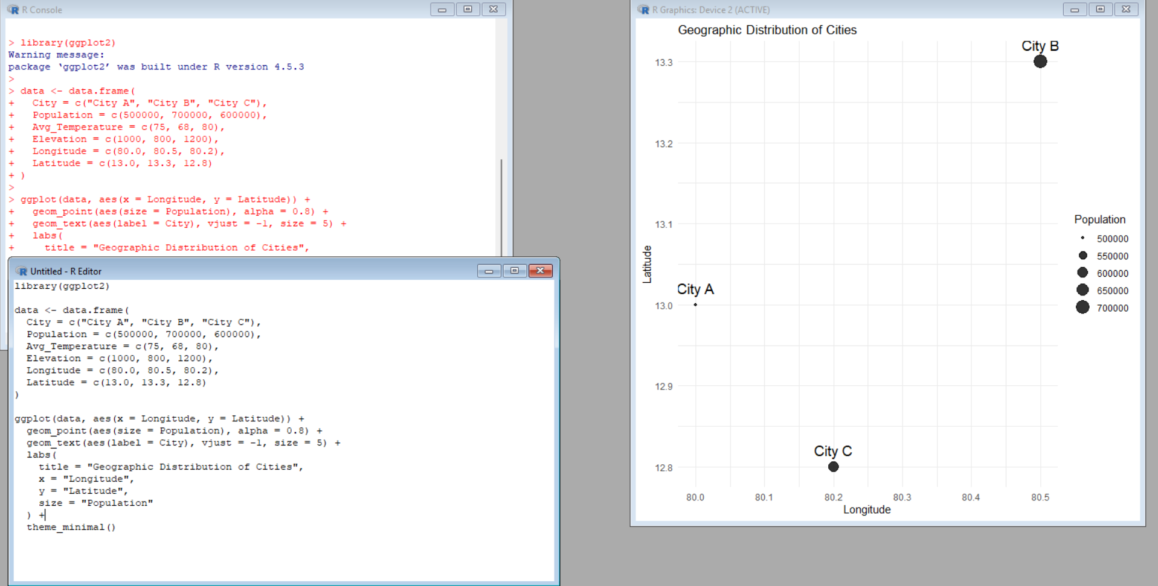
QUESTION 2: Generate a scatter plot to explore the relationship between average temperature and population size. Explain any insights.
AIM
To generate a scatter plot showing the relationship between average temperature and population size of the cities.
ALGORITHM
1. Create the geographic data frame.
2. Take average temperature as the X-axis variable.
3. Take population as the Y-axis variable.
4. Plot each city as a point.
5. Add city labels.
6. Observe the relationship between temperature and population.
R CODE
data <- data.frame(
City = c("City A", "City B", "City C"),
Population = c(500000, 700000, 600000),
Avg_Temperature = c(75, 68, 80),
Elevation = c(1000, 800, 1200)
)
library(ggplot2)
library(ggrepel)
ggplot(data, aes(x = Avg_Temperature, y = Population)) +
geom_point(size = 4) +
geom_text_repel(aes(label = City)) +
labs(title = "Average Temperature vs Population",
x = "Average Temperature",
y = "Population") +
theme_minimal()
OBSERVATION
City B has the highest population (700,000) but the lowest average temperature (68). City C has the highest temperature (80) with a population of 600,000. Therefore, the three cities do not show a simple direct relationship between temperature and population.
RESULT
The scatter plot was successfully generated and the relationship between average temperature and population was analyzed.
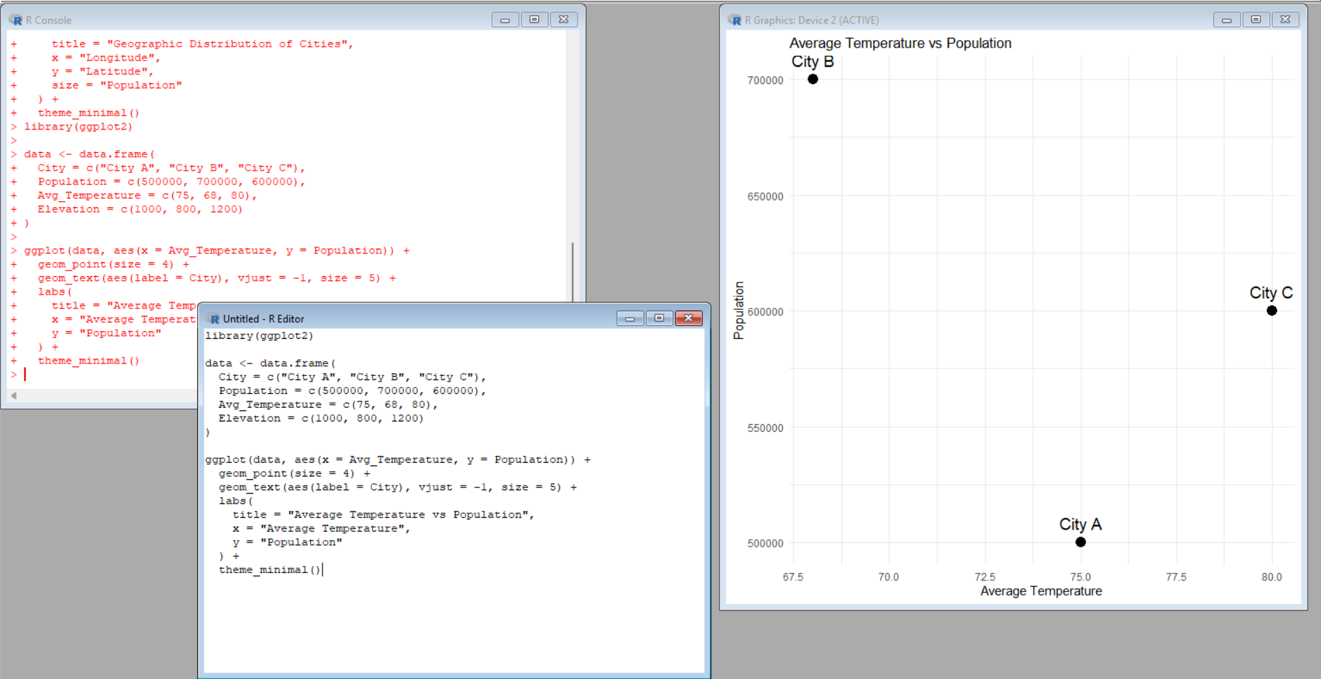
QUESTION 3: Build a table to display the geographic data for each city. Label the table elements.
AIM
To create and display a clearly labelled table containing the geographic data of each city.
ALGORITHM
1. Create the data frame with City, Population, Average Temperature, and Elevation.
2. Select the required columns.
3. Display the data in tabular form.
4. Check that all city values are correctly labelled.
R CODE
data <- data.frame(
City = c("City A", "City B", "City C"),
Population = c(500000, 700000, 600000),
Avg_Temperature = c(75, 68, 80),
Elevation = c(1000, 800, 1200)
)
print(data)
OBSERVATION
The table clearly displays the values for all three cities. City B has the highest population, while City C has the highest average temperature and elevation.
RESULT
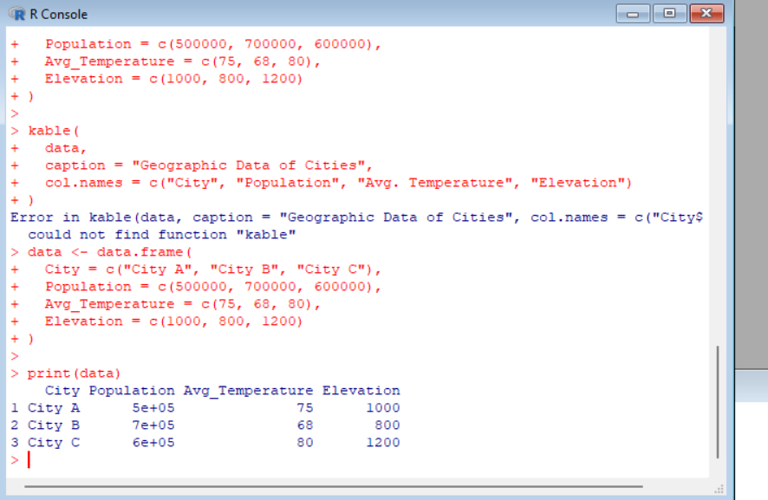
The geographic data for City A, City B, and City C was successfully displayed in a labelled table.
QUESTION 4: Develop a Tableau dashboard combining the map chart, scatter plot, and table for interactive exploration of geographic data.
AIM
To develop an interactive Tableau dashboard by combining the map chart, scatter plot, and geographic data table.
ALGORITHM
1. Open Tableau Desktop or Tableau Public.
2. Connect the geographic dataset.
3. Create a Map Chart using Longitude and Latitude, with City as the label and Population as the size.
4. Create a Scatter Plot using Average Temperature on Columns and Population on Rows, with City as the label.
5. Create a Table containing City, Population, Average Temperature, and Elevation.
6. Create a new Dashboard.
7. Drag the map, scatter plot, and table sheets into the dashboard.
8. Add titles, labels, and interactive filters/highlighting.
9. Save the dashboard.
TABLEAU PROCEDURE
1. Map Sheet: Put Longitude in Columns, Latitude in Rows, City in Label, and Population in Size.
2. Scatter Sheet: Put Avg. Temperature in Columns, Population in Rows, and City in Label.
3. Table Sheet: Add City, Population, Avg. Temperature, and Elevation.
4. Dashboard: Combine all three sheets in one dashboard and format the titles and labels.
OBSERVATION
The dashboard combines the geographic location view, temperature-population relationship, and detailed city data in one screen. Selecting or highlighting a city can help compare its related values.
RESULT
An interactive Tableau dashboard was successfully designed by combining the map chart, scatter plot, and table for geographic data exploration.
OVERALL RESULT
All four questions were completed separately. The geographic data was visualized using a map chart, scatter plot, table, and an interactive Tableau dashboard.

